AH 321
Body Composition Laboratory
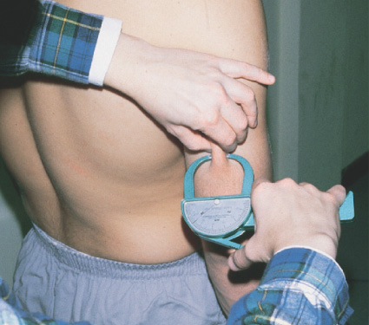
Triceps - With the arm resting comfortably at its side, take a vertical fold parallel to the long axis of the arm midway between the tip of the shoulder and the tip of the shoulder and the tip of the elbow. | Biceps - With the arm resting comfortably at its side, take a vertical fold halfway between the elbow and the top of the shoulder on the front of the upper arm.
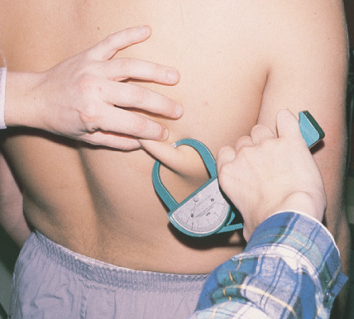 | 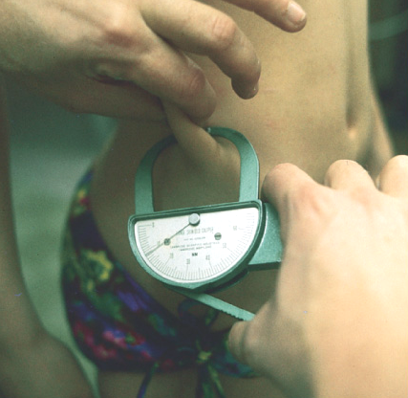
Subscapula – Just below the scapula, take a diagonal fold across the back. | Suprailiac – Just above the crest of the ilium, take a diagonal fold following the natural line of the iliac crest.
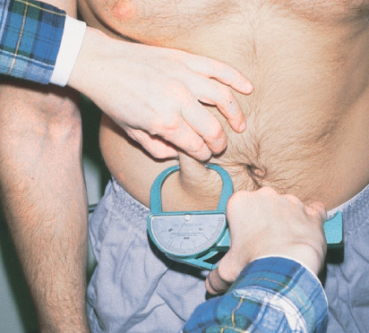 | 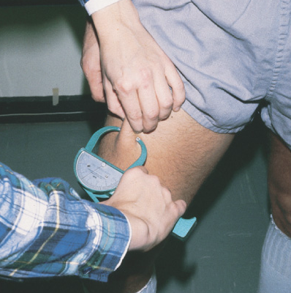
Abdominal skinfold - horizontal fold taken adjacent to the umbilicus | Thigh skinfold - vertical fold on the anterior aspect of the thigh taken midway between the hip and the knee joints
Take the following skin fold measurements on your classmates and record.

Use the following formula to determine the skin fold totals from your measurements:

_____ + | _____ + | _____ + | _____ = | _______
Triceps | Biceps | Subscapula | Suprailiac | Total skin fold | Body fat percent
Use the total skin fold from the above formula in conjunction with Table 6.3 to determine the percent of body fat for each class member and record appropriately.

Use the Skyndex ® as indicated to determine body fat percentages on the following patients.

Benavidez | Megan | _____ +  Triceps | _____ +  Biceps | _____ +  Subscapular | _____ =  Suprailiac | Total skin fold | Body fat percent
Bradshaw | Amanda | _____ +  Triceps | _____ +  Biceps | _____ +  Subscapular | _____ =  Suprailiac | Total skin fold | Body fat percent
Davis | Shawndra | _____ +  Triceps | _____ +  Biceps | _____ +  Subscapular | _____ =  Suprailiac | Total skin fold | Body fat percent
Lay | Brandy | _____ +  Triceps | _____ +  Biceps | _____ +  Subscapular | _____ =  Suprailiac | Total skin fold | Body fat percent
Mathis | Amanda | _____ +  Triceps | _____ +  Biceps | _____ +  Subscapular | _____ =  Suprailiac | Total skin fold | Body fat percent
Parrish | Rina | _____ +  Triceps | _____ +  Biceps | _____ +  Subscapular | _____ =  Suprailiac | Total skin fold | Body fat percent
Pritchard | Aidan | _____ +  Triceps | _____ +  Biceps | _____ +  Subscapular | _____ =  Suprailiac | Total skin fold | Body fat percent
Stevens | Emily | _____ +  Triceps | _____ +  Biceps | _____ +  Subscapular | _____ =  Suprailiac | Total skin fold | Body fat percent
Sum |  | _____ +  Triceps | _____ +  Biceps | _____ +  Subscapular | _____ =  Suprailiac | Total skin fold | Body fat percent
Total # measured |  | _____ | _____ | _____ | _____ | _____ | _____
Sum  Total # measured |  | _____ | _____ | _____ | _____ | _____ | _____

Dooley | Keith | _____ +  Triceps | _____ +  Biceps | _____ +  Subscapular | _____ =  Suprailiac | Total skin fold | Body fat percent
Knighten | Fred | _____ +  Triceps | _____ +  Biceps | _____ +  Subscapular | _____ =  Suprailiac | Total skin fold | Body fat percent
McCrary | Chris | _____ +  Triceps | _____ +  Biceps | _____ +  Subscapular | _____ =  Suprailiac | Total skin fold | Body fat percent
Shoemaker | Johnathan | _____ +  Triceps | _____ +  Biceps | _____ +  Subscapular | _____ =  Suprailiac | Total skin fold | Body fat percent
Sum |  | _____ +  Triceps | _____ +  Biceps | _____ +  Subscapular | _____ =  Suprailiac | Total skin fold | Body fat percent
Total # measured |  | _____ | _____ | _____ | _____ | ___________ | _____________
Sum  Total # measured |  | _____ | _____ | _____ | _____ | ___________ | _____________

Benavidez | Megan | Skyndex #1 | Skyndex #2
Bradshaw | Amanda | Skyndex #1 | Skyndex #2
Davis | Shawndra | Skyndex #1 | Skyndex #2
Lay | Brandy | Skyndex #1 | Skyndex #2
Mathis | Amanda | Skyndex #1 | Skyndex #2
Parrish | Rina | Skyndex #1 | Skyndex #2
Pritchard | Aidan | Skyndex #1 | Skyndex #2
Stevens | Emily | Skyndex #1 | Skyndex #2
Sum |  | ___________ | ____________
Total # measured |  | ___________ | ____________
Sum  Total # measured |  | ___________ | ____________

Dooley | Keith | Skyndex #1 | Skyndex #2
Knighten | Fred | Skyndex #1 | Skyndex #2
McCrary | Chris | Skyndex #1 | Skyndex #2
Shoemaker | Johnathan | Skyndex #1 | Skyndex #2
Sum |  | ___________ | ______________
Total # measured |  | ___________ | ______________
Sum  Total # measured |  | ___________ | ______________

