 | The University of West Alabama  Athletic Training & Sports Medicine Center  Station #14, UWA  Livingston, AL 35470  205-652-3450  http://at.uwa.edu | 

Ankle Rehabilitation

- ANKLE PUMPING: Increase ROM and circulation by first pointing your toes downward ,then up, in slow steady motions. Repeat___ times. | 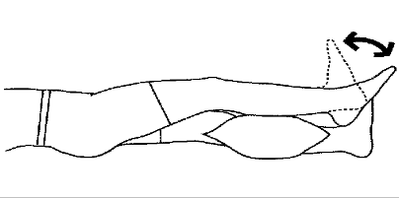
- ANKLE ALPHABET: Sit comfortably with your legs stretched out in front of you. Now trace the letters of the alphabet with your big toe, making sure that the motion involves the ankle. | 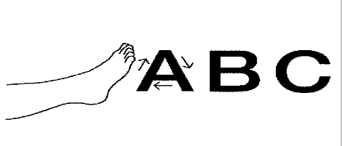
- ANKLE CIRCLES: Using your big toe as an indicator, make circles with your ankle, first clockwise, then counter-clockwise, ___ times. Be sure that the motion is at the ankle and not just the foot. | 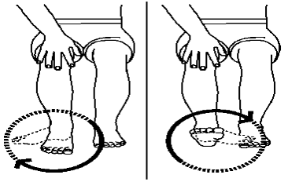
- INVERSION/EVERSION ROM: Sit with your feet flat on the floor. Turn the soles of your feet inward so that they face each other. Then turn the outward, as far as possible. Repeat___ times. | 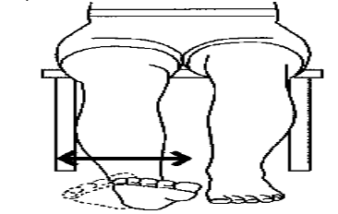
- ACHILLES STRETCH, LONG SITTING: While sitting with your knee straight, place a towel around the bottom of your foot, with an end in each hand. Slowly pull towel until you feel a gentle stretch in your | 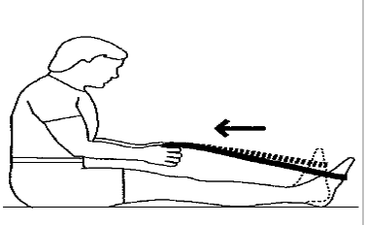
- ACHILLES STRETCH, KNEE BENT: Sit with knee bent to a 90 degree angle and loop a towel around the bottom of your foot, with an end in each hand. Slowly pull towel until you feel a gentle stretch in your calf. Hold at least ____ seconds, then relax. Repeat ___times.
- ACHILLES STRETCH, GASTROCNEMIUS: Stand facing a wall, with one foot in front of the other. Lean forward with your hands on the wall. Bend the front leg, leaving the rear leg straight and keeping both heels on the floor. Continue until you feel a gentle stretch. Hold for ___seconds, then repeat with the other leg forward. Repeat ____times. | 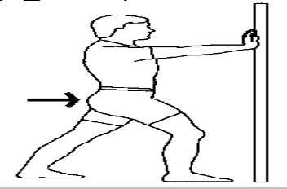
- ACHILLES STRETCH, SOLEUS: Stand facing a wall, with one foot in front of the other. Lean forward with your hands on the wall. Bend both legs slightly, keeping both heels on the floor .Continue until you feel a gentle stretch. Hold for ___seconds, then repeat with the other leg forward. Repeat ____times.
- SLANTBOARD STRETCH:
_____a) Stand with heels on board and lean forward
_____b) Turn toes in with heels on board and lean forward
_____c) Stand with knees bent and heels down
_____d) Stand with knees bent, point toes inward keeping heels down on the board
- ARCH STRETCH: Seated, feet on floor, place foot over rolling pin, coke bottle, or golf ball, etc., with slight to moderate pressure. Roll foot from heels to toes and reverse. Repeat ____times with each foot. | 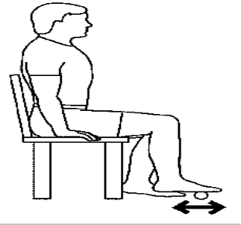
- HAMSTRING STRETCHING: Straighten supported leg with the opposite leg off the side of a table or bed. Slowly lean forward until you feel a stretch in the back muscles of your thigh (hamstrings). Hold for ____seconds, then relax. Repeat _____times with each foot. | 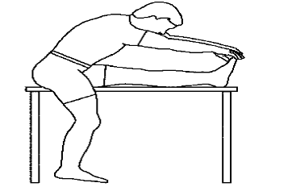
- BALANCING:
_____a). Standing on injured ankle
_____b). Stand on injured ankle with eyes closed
_____c). Knee bent, stand on injured ankle
_____d). Knee bent, eyes closed, stand on injured ankle
- TILTBOARD: Place foot in center of tilt board. Rotate foot so that the edge of the circle touches the floor in a constant motion  _____a). Seated (CW____; CCW ____)  _____b). Standing, knees bent (CW ____; CCW ____)  _____c). Standing, knees straight (CW ____; CCW ____) | 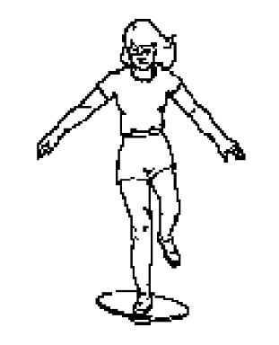
- WOBBLE BOARD, COMPASS POINTS: Stand on a wobble board in a doorway (for support). Begin by pressing your toes down. Now rock back on your heels. Go slowly, maintaining control. Press next to the left (west) then to the right (east). Repeat entire sequence ____times. For advanced exercises: add the intermediate compass points (NE, SW, NW, and SE). More Advanced: Stand on one foot. | 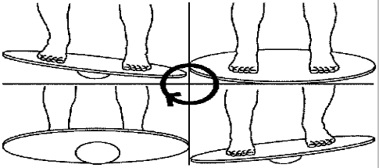
- WOBBLE BOARD, BALANCE: Stand on the wobble board with your weight evenly distributed over both feet. Use a counter or wall for support if necessary. Try to stand for _____seconds without the edges of the balance board touching the floor. Repeat ____ times. (Advanced: Attempt balancing on a single leg).
- HEEL RAISES, SITTING: Sit with both feet on the floor. Now raise your heels as high as possible, while keeping your toes on the floor. Return to the starting position and repeat ____times. | 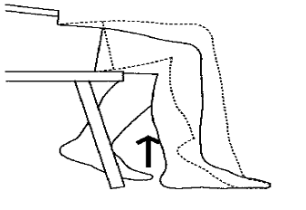
- HEEL RAISES, STANDING: Raise up on your toes as far as possible from a standing position (use a chair back or wall for balancing support if necessary). Perform ____sets of ____repetitions. (Advanced: Repeat on just one foot). | 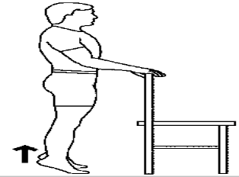
- HEEL RAISES, ON STEP: Stand with the balls of your feet on the edge of a step, holding on the wall for support. Slowly lower heels as far as possible. Hold for ____seconds. Now rise on your toes, again as far as possible. Repeat ____times. | 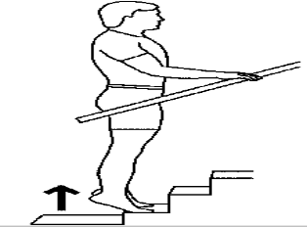
- WALKING ON HEELS: Lift your toes off the floor and walk on your heels. Try to keep your toes as far from the floor as possible. Walk about ____feet. Repeat ____times. | 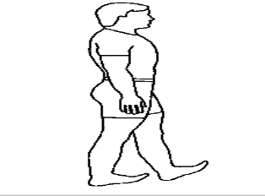
- WALKING ON TOES: Rise up on your toes and walk. Try to stay as high on your toes as possible. Walk about ____feet. Repeat ____times. | 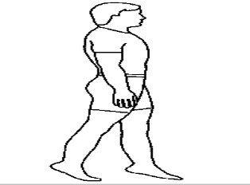
- WALKING, HEEL TO TOE: Walk across a room, exaggerating ankle motion by first touching your heel to the ground with your toes lifted high, the going on your toes as the end of that step. Walk about ____feet. Repeat ____times. | 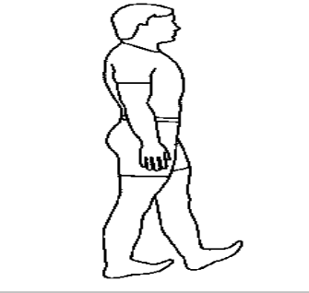
- PLANTERFLEXION, TOWEL RESISTANCE: While sitting with your knees straight, place a towel around the bottom of your foot, with an end in each hand. Gently pull back, then push with your foot against the resistance, until your toes are pointing as far as possible. Return to the starting position. Repeat ____times.
- PLANTARFLEXION, ELASTIC RESISTANCE: Sit on the floor with an elastic loop around your foot as shown. Press down as far as possible against the resistance, until your toes are pointing as far as possible. Return to the starting position. Repeat ____times.
- DORSIFLEXION, ELASTIC RESISTANCE: Attach an elastic loop to a stable chair leg with the other end around your foot. Pull your toes and foot up toward your head, against resistance. Go as far as possible, adjusting the resistance. Keep motions slow. Repeat ____times. | 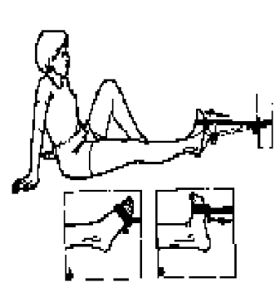
- TOWEL GATHERING: Sit in a chair on a non-carpeted floor with a small towel spread out in front of you. Gather the towel as much as possible. Progress is often slow, so keep trying. Straighten the towel and repeat ____times. Advanced: Place ____pounds on end of towel. | 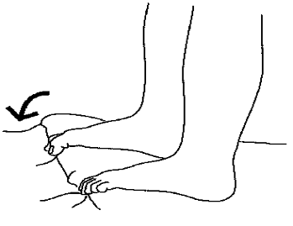
- NUMBER HOPS:
_____a) “1-2-3-4” ____sets, ____reps
_____b) “4-3-2-1” ____sets, ____reps
_____c) “1-3-2-4” ____sets, ____reps
_____d) “4-2-3-1” ____sets, ____reps
- ICE MASSAGE: Freeze some water in a paper cup. When frozen, peel the cup back, exposing the ice. With light pressure rub the area in a circular motion. You will feel three phases of sensation: first cold, then painful (stinging) and finally numbness. Perform for ____minutes ____times daily including:

_____a) before rehabilitation
_____b) after rehabilitation
_____c) end of the day
- ICE: Apply ice to the front and back of the injured area for ____ minutes ____times daily including:

_____a) before rehabilitation
_____b) after rehabilitation
_____c) end of the day

