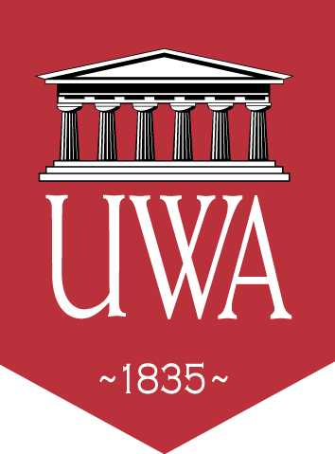 |  | The University of West Alabama  2012 Football Breakfast & Pre-Game Menus for Road Games |  | 
 | For night games |  | For afternoon games
 | Sat. Sept. 1 @ Clark Atlanta University –Atlanta, GA 5:00 pm  Sat., Sept. 8 @Samford University -- Birmingham 6 pm  Sat., Sept. 22 @ Valdosta State University$ -- Valdosta, GA 6 pm |  | Sat., Oct. 27 @ Delta State University-- Cleveland, MS 4 pm  Sat. Nov. 3 @ Abilene Christian University – Abilene, TX 12 pm
Breakfast | - Scrambled Eggs  - Grits  - Bacon & Sausage  - Pancakes  - Syrup  - Butter  - 1 cup of Fruit  - Toast & Biscuits  - Honey  - Orange Juice  - Milk
Pre-Game Meal | - Grilled Chicken Breast  - Green Beans & Corn  - Baked Potato  - Butter  - Sour cream  - 1 cup of Fruit  - Dinner Rolls  - Ketchup  - Steak sauce  - 32-64 ounces of Gatorade or Powerade |  | - Grilled Chicken Breast  - Scrambled Eggs  - Grits  - Pancakes  - Syrup  - Butter  - 1 cup of Fruit  - Toast & Biscuits  - Honey  - Ketchup & Steak sauce  - 32-64 ounces of Gatorade or Powerade

