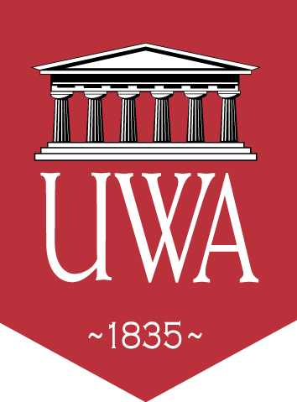 | Itinerary  The University of West Alabama “TIGERS”  vs. Concordia College  September 26, 2013 | 

Saturday, September 26, 2013
2:45 Load Bags on Bus
3:10 Board Bus
3:20 Bus Departs for Demopolis, AL
3:50 Arrive – Demopolis High School Football Stadium
6:00 Kickoff - Beat Concordia College!
9:00 Load bags on bus - Pick up post-game meal at bus
9:20 Board bus
9:30 Bus departs for Livingston
10:00 Arrive UWA - Put equipment in locker

