Harding University Game from UWA
September 29-30, 2006
Time | Mile | Instruction | For | Toward
9:00 AM | 0.0 | Depart near Livingston on Local road(s) (West) | 65 yds
9:00 AM | 0.1 | Turn RIGHT (North) onto Hopkins St | 0.8 mi
9:01 AM | 0.8 | Turn RIGHT to stay on Hopkins St | 0.2 mi
9:01 AM | 1.0 | Turn LEFT (West) onto Lake Dr | 0.3 mi
9:02 AM | 1.3 | At 99 Lake Dr, Livingston, AL 35470, stay on Lake Dr (West) | 32 yds
9:02 AM | 1.3 | Bear LEFT (North) onto Country Club Rd | 1.5 mi
9:05 AM | 2.8 | Turn LEFT (North-West) onto SR-28 | 6.8 mi
9:15 AM | 9.6 | Turn RIGHT (North) onto SR-17 | 13.2 mi
9:29 AM | 22.8 | At CR-30, Emelle, AL 35459, turn LEFT (West) onto CR-30 | 2.9 mi
9:32 AM | 25.7 | Entering Mississippi
9:32 AM | 25.7 | Road name changes to SR-16 | 6.2 mi
9:41 AM | 31.8 | At SR-16, Scooba, MS 39358, stay on SR-16 (West) | 54 yds
9:41 AM | 31.9 | Bear RIGHT (North) onto US-45, then immediately turn RIGHT (East) onto Binnsville Rd [Old 45] | 0.3 mi
9:42 AM | 32.2 | Turn RIGHT to stay on Binnsville Rd [Old 45] | 2.0 mi
9:43 AM | 34.2 | Keep STRAIGHT onto Binnsville Rd [Old 45 Rd] | 131 yds
9:43 AM | 34.3 | Bear LEFT (North) onto Old 45 Rd | 4.2 mi
9:48 AM | 38.5 | Turn RIGHT (North) onto Sparkman Rd | 2.8 mi
9:52 AM | 41.3 | Bear LEFT (North-West) onto Field Rd | 1.6 mi
9:55 AM | 42.9 | Turn RIGHT to stay on Field Rd | 2.1 mi
9:57 AM | 45.0 | Turn RIGHT to stay on Field Rd | 0.4 mi
9:58 AM | 45.4 | Turn RIGHT (North) onto US-45 | 7.0 mi
10:12 AM | 52.4 | Turn LEFT (West) onto Local road(s) | 76 yds
10:13 AM | 52.4 | Bear RIGHT (North-West) onto SR-145 | 2.4 mi
10:17 AM | 54.8 | Keep STRAIGHT onto SR-14 [SR-145] | 0.4 mi
10:18 AM | 55.2 | Keep STRAIGHT onto SR-145 [Jefferson St] | 0.2 mi
10:19 AM | 55.5 | Keep STRAIGHT onto SR-145 [S Jefferson St] | 174 yds
10:19 AM | 55.6 | Keep STRAIGHT onto SR-145 [N Jefferson St] | 1.0 mi
10:20 AM | 56.5 | Keep STRAIGHT onto SR-145 [Jefferson St] | 0.1 mi
10:20 AM | 56.7 | Keep STRAIGHT onto SR-145 | 3.1 mi
10:25 AM | 59.8 | Turn LEFT (North) onto US-45 | 4.6 mi
10:34 AM | 64.4 | Keep STRAIGHT onto US-45 Alt | 49.8 mi | US-45 Alternate North
 |  | Resurfacing between Artesia and Columbus (May 8, 2006 - April 27, 2007)
11:26 AM | 114.1 | Turn LEFT (West) onto US-45 Bus | 3.9 mi
11:30 AM | 118.1 | Keep STRAIGHT onto US-45 Bus [S Church St] | 1.3 mi
11:32 AM | 119.4 | Keep STRAIGHT onto US-45 Bus [N Church St] | 1.8 mi
11:34 AM | 121.2 | Keep STRAIGHT onto US-45 Bus | 6.9 mi
11:41 AM | 128.0 | Keep STRAIGHT onto SR-145 | 1.7 mi
11:43 AM | 129.7 | Turn RIGHT (East) onto Brewer Rd | 1.2 mi
11:45 AM | 130.9 | Turn LEFT to stay on Brewer Rd | 131 yds
11:46 AM | 131.0 | Take Ramp (RIGHT) onto US-45 [Martin Luther King Dr] | 10.4 mi | US-45 / Tupelo
11:54 AM | 141.4 | Take Ramp (RIGHT) onto US-78 [Appalachian Hwy] | 0.6 mi | US-78 / Memphis
11:55 AM | 142.0 | Turn LEFT (East) onto Local road(s) | 131 yds
11:55 AM | 142.1 | At US-78 US-45 Exit, return West on Local road(s) | 131 yds
11:55 AM | 142.2 | Merge onto US-78 [Appalachian Hwy] | 83.4 mi
1:00 PM | 225.6 | Keep RIGHT onto Ramp | 0.2 mi | MS-302 / Olive Branch / Southaven
1:00 PM | 225.8 | Keep LEFT to stay on Ramp | 65 yds | MS-302 / Southaven
1:00 PM | 225.8 | Keep STRAIGHT onto Local road(s) | 21 yds
1:00 PM | 225.8 | Turn LEFT (West) onto SR-302 [Goodman Rd] | 8.9 mi | MS-302
1:09 PM | 234.7 | Arrive Ryan's Family Steakhouse
2:09 PM | 234.7 | Depart Ryan's Family Steakhouse on SR-302 [Goodman Rd] (East) | 0.6 mi
2:09 PM | 235.3 | Take Ramp (RIGHT) onto I-55 | 8.2 mi | I-55 / Memphis
2:11 PM | 237.7 | Entering Tennessee
 |  | Construction near Whitehaven (NB) (August 8, 2005 - July 31, 2008)
2:16 PM | 243.5 | Take Ramp (LEFT) onto I-55 | 6.1 mi | I-55 / St Louis
2:21 PM | 249.6 | Take Ramp (RIGHT) onto I-55 [US-61] | 5.4 mi | I-55 / US-61 / St Louis / Little Rock
2:22 PM | 250.4 | Entering Arkansas
2:25 PM | 254.9 | Merge onto I-40 [I-55] | 2.5 mi
2:27 PM | 257.5 | At exit 277, take Ramp (RIGHT) onto I-55 [US-61] | 2.8 mi | I-55 / Blytheville / Jonesboro
2:29 PM | 260.2 | At exit 10, turn RIGHT onto Ramp | 98 yds | US-64 / Marion / Sunset / Wynne
2:29 PM | 260.3 | Bear LEFT (North) onto US-64 | 0.2 mi
2:30 PM | 260.5 | Turn LEFT (West) onto US-64 [Military Rd] | 49.9 mi
3:20 PM | 310.5 | Keep STRAIGHT onto US-49 [US-64] | 109 yds
3:21 PM | 310.5 | Keep STRAIGHT onto US-64 | 32.1 mi
3:53 PM | 342.6 | Road name changes to US-167 [US-64] | 0.1 mi
3:54 PM | 342.7 | Bear LEFT (North-West) onto Ramp | 0.4 mi | US-167 / US-67 / US-64
3:54 PM | 343.1 | Road name changes to US-167 [US-64] | 8.6 mi
4:01 PM | 351.7 | At exit 46, keep RIGHT onto Ramp | 0.3 mi | AR-36 / US-67-BR / Searcy / Kensett
4:01 PM | 352.0 | Keep RIGHT to stay on Ramp | 32 yds | AR-36 / US-67-BR / AR-16 / Searcy / Heber Springs
4:01 PM | 352.0 | Bear RIGHT (West) onto US-67 Bus [SR-36] | 2.1 mi
4:04 PM | 354.1 | Turn LEFT (South) onto N Grand St | 0.1 mi
4:05 PM | 354.2 | Turn RIGHT (West) onto E Center Ave | 98 yds
4:05 PM | 354.3 | At Harding University, return East on E Center Ave | 0.3 mi
4:06 PM | 354.6 | Turn RIGHT (South) onto S Cross St | 0.2 mi
4:06 PM | 354.7 | Arrive 1213 E Park Ave, Searcy, AR 72143
4:51 PM | 354.7 | Depart 1213 E Park Ave, Searcy, AR 72143 on E Park Ave (East) | 0.5 mi
4:52 PM | 355.3 | Turn RIGHT (South) onto Benton St | 1.8 mi
4:55 PM | 357.0 | Turn LEFT (South) onto SR-267 [SR-367] | 174 yds
4:56 PM | 357.1 | Take Ramp (RIGHT) onto US-167 [US-64] | 43.5 mi | US-167 / US-67 / US-64
5:29 PM | 400.6 | Merge onto I-40 [US-167] | 1.2 mi
5:30 PM | 401.9 | At exit 153A, turn RIGHT onto Ramp | 0.3 mi | AR-107
5:31 PM | 402.2 | Keep LEFT to stay on Ramp | 43 yds
5:31 PM | 402.2 | Bear RIGHT (North) onto Local road(s) | 10 yds
5:31 PM | 402.2 | Turn LEFT (South-West) onto SR-107 [John F Kennedy Blvd] | 0.3 mi
5:32 PM | 402.5 | Keep STRAIGHT onto SR-107 [N Main St] | 43 yds
5:32 PM | 402.5 | Take Local road(s) (RIGHT) onto W Pershing Blvd | 98 yds
5:33 PM | 402.6 | Arrive Howard Johnson [111 W Pershing Blvd, North Little Rock, AR 72114, (501) 758-1440]
6:18 PM | 402.6 | Depart Howard Johnson [111 W Pershing Blvd, North Little Rock, AR 72114, (501) 758-1440] on W Pershing Blvd (West) | 0.4 mi
6:18 PM | 403.0 | Turn RIGHT (North) onto SR-176 [Percy Machin Rd] | 0.2 mi
6:19 PM | 403.2 | Take Ramp (RIGHT) onto I-40 [US-65] | 2.3 mi | I-40
6:21 PM | 405.6 | Keep LEFT onto US-167 [US-67] | 1.0 mi | US-67 / US-167
6:22 PM | 406.6 | At exit 1A, keep RIGHT onto Ramp | 0.3 mi | McCain Blvd. E.
6:22 PM | 406.8 | Turn RIGHT (East) onto E McCain Blvd | 0.3 mi
6:23 PM | 407.1 | Arrive 3694 Springhill Dr, North Little Rock, AR 72117
7:23 PM | 407.1 | Depart 3694 Springhill Dr, North Little Rock, AR 72117 on Springhill Dr (South) | 0.6 mi
7:24 PM | 407.7 | Take Ramp (RIGHT) onto I-40 | 2.4 mi | I-40 / Little Rock / Fort Smith
7:26 PM | 410.1 | At exit 153A, turn RIGHT onto Ramp | 0.3 mi | AR-107
7:26 PM | 410.4 | Keep LEFT to stay on Ramp | 43 yds
7:26 PM | 410.4 | Bear RIGHT (North) onto Local road(s) | 10 yds
7:26 PM | 410.4 | Turn LEFT (South-West) onto SR-107 [John F Kennedy Blvd] | 0.3 mi
7:27 PM | 410.7 | Keep STRAIGHT onto SR-107 [N Main St] | 43 yds
7:27 PM | 410.7 | Take Local road(s) (RIGHT) onto W Pershing Blvd | 98 yds
7:28 PM | 410.8 | Arrive Howard Johnson [111 W Pershing Blvd, North Little Rock, AR 72114, (501) 758-1440]
DAY 2
Time | Mile | Instruction | For | Toward
2:13 PM | 410.8 | Depart Howard Johnson [111 W Pershing Blvd, North Little Rock, AR 72114, (501) 758-1440] on W Pershing Blvd (West) | 0.4 mi
2:14 PM | 411.2 | Turn RIGHT (North) onto SR-176 [Percy Machin Rd] | 0.2 mi
2:15 PM | 411.5 | Take Ramp (RIGHT) onto I-40 [US-65] | 2.3 mi | I-40
2:17 PM | 413.8 | Keep LEFT onto US-167 [US-67] | 9.3 mi | US-67 / US-167
2:24 PM | 423.1 | At exit 10A, bear RIGHT (East) onto Ramp, then immediately bear LEFT (North-East) onto T P White Dr [US-167] | 0.6 mi | James St.
2:24 PM | 423.7 | Turn LEFT (North) onto N James St | 0.5 mi
2:25 PM | 424.2 | Turn RIGHT (East) onto Gregory St | 0.3 mi
2:26 PM | 424.5 | Arrive Gregory St, Jacksonville, AR 72076
3:26 PM | 424.5 | Depart Gregory St, Jacksonville, AR 72076 on Gregory St (West) | 0.3 mi
3:27 PM | 424.8 | Turn LEFT (South) onto N James St | 0.5 mi
3:28 PM | 425.3 | Turn LEFT (North-East) onto T P White Dr [US-167] | 164 yds
3:28 PM | 425.4 | Take Ramp (LEFT) onto US-167 [US-67] | 31.8 mi | US-167 / US-67
3:53 PM | 457.1 | At exit 42, keep RIGHT onto Ramp | 0.3 mi | AR-367 / US-67-BR / Searcy
3:54 PM | 457.4 | Turn LEFT (North) onto US-67 Bus [SR-367] | 3.2 mi
3:58 PM | 460.6 | Turn RIGHT (East) onto E Park Ave | 0.8 mi
3:59 PM | 461.4 | Arrive 1213 E Park Ave, Searcy, AR 72143
SUMMARY
Driving distance: 461.4 miles
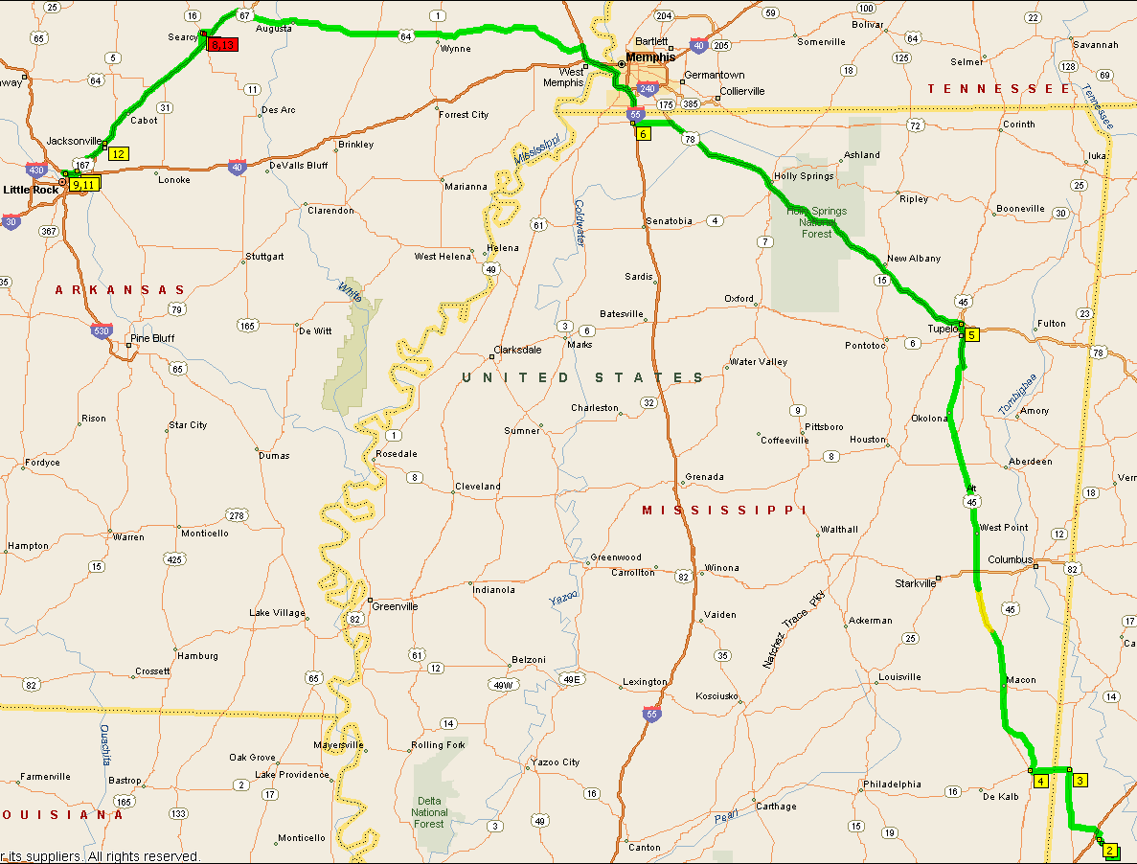
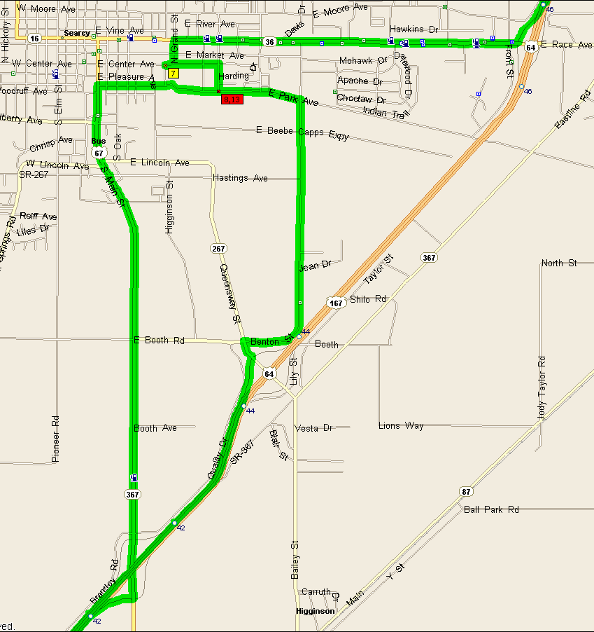 | 