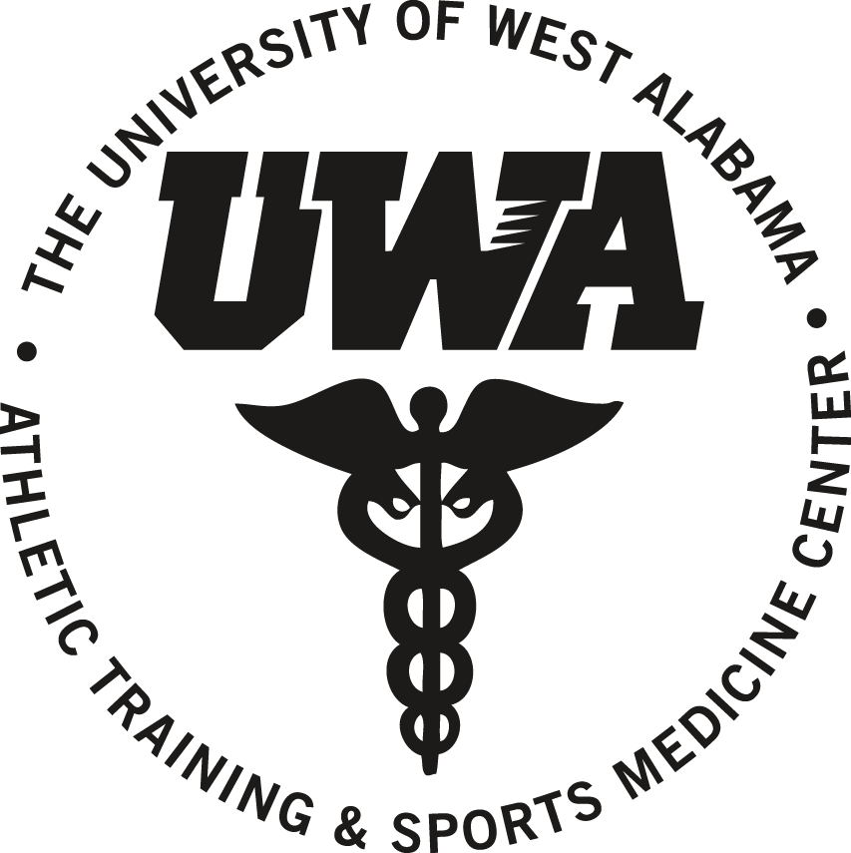 | The University of West Alabama Athletic Training & Sports Medicine Center  Referral to Rush Medical Group, Livingston
 |  |  |  | Name:
 | Today’s Date: |  |  |  |  | LAST |  | FIRST |  | M.I.
 | Sport |  |  |  |  | Date of Birth
The above UWA student has been evaluated by the UWA Athletic Training & Sports Medicine Center Staff and is being referred to Rush Medical Group, Livingston for further evaluation and treatment.
 | Differential Diagnosis/Primary Complaint
 | UWA ATSMC Staff |  |  |  |  |  |  |  | Date
Give this copy to student to present to receptionist at Rush Medical Group, Livingston.

- - - -- - -- - Tear in half - - - - -- - -- - Tear in half - - - - -- - -- -Tear in half - - - - -- - -- - Tear in half - - - - - -- -

The University of West Alabama Athletic Training & Sports Medicine Center

Referral to Rush Medical Group, Livingston

 |  |  |  | Name:
 | Today’s Date: |  |  |  |  | LAST |  | FIRST |  | M.I.
 | Sport |  |  |  |  | Date of Birth
The above UWA student has been evaluated by the UWA Athletic Training & Sports Medicine Center Staff and is being referred to Rush Medical Group, Livingston for further evaluation and treatment.
 | Differential Diagnosis/Primary Complaint
 | UWA ATSMC Staff |  |  |  |  |  |  |  | Date
Place this copy in the second tray above mailboxes in UWA AT&SMC.

