 | The University of West Alabama  Athletic Training & Sports Medicine Center  Station #14, UWA  Livingston, AL 35470  205-652-3450  http://at.uwa.edu | 
Shoulder Rehabilitation Program

Range of Motion Exercises:
- Pendulum
Lean over table, supporting body with uninvolved arm. Let involved arm hang straight down in a relaxed position. Move your hips to cause the shoulder to move first side-to-side and then in circles, forward, and backward. Begin with small movements and gradually increase. Shoulder should move passively. Repeat _____ sets of ______, _____ daily, _____ weekly.
- Rope and Pulley
The overhead rope and pulley should be positioned in doorway. Sit in chair with back against door, directly underneath pulley.
- Shoulder Flexion:
With elbow straight and thumb facing upward, raise involved arm out to the front of body as high as possible. Assist as needed by pulling down with uninvolved arm. Hold overhead 5 second and repeat.

- Shoulder Abduction:
With elbow straight and palm against side, raise involved arm to the side of body as high as possible, turning the palm up as you approach 90. Assist as needed by pulling down with the uninvolved arm to control lowering and repeat.

T-Bar Exercises

- Shoulder Flexion:
Lie on back and grip T-bar between index finger and thumb, elbows straight. Raise both arms overhead as far as possible keeping thumbs up. Hold for 5 seconds and repeat.

- Shoulder Abduction:  Lie on back with involved arm at side of body, elbow straight and palm against leg. With other hand, push arm overhead, keeping the arm parallel to your side. As the arm reaches 90, turn palm upwards. Twisting the uninvolved hand up can help. Continue overhead with palm up. Hold at end position 5 seconds and repeat. | 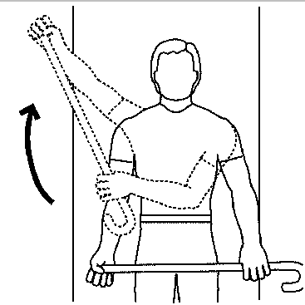
- External Rotation  Lie on back with involved arm against body and elbow bent at 90. Grip T-bar handle and with uninvolved arm, push involved shoulder into external rotation. Hold for 5 seconds. Return to starting position and repeat. | 