The University of West Alabama
Athletic Training & Sports Medicine Center

R.T. Floyd, EdD, ATC, CSCS
Bradley S. Montgomery, MAT, ATC
Andy Grubbs, MSEd, ATC
Station #14
Livingston, AL 35470
(205) 652-3450
http:at.uwa.edu

Mary L. Jones, PhD, ATC
Stephanie Bura, ATC
Shanna Grubbs, ATC

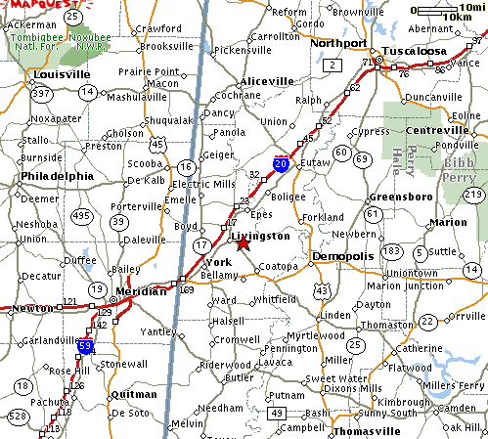 |  |  | 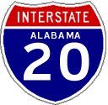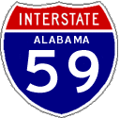  Traveling north/east (from Mississippi Area) on I-59/I-20, take the AL-28 exit, exit #17 (Livingston/Boyd). Turn right onto AL-28. Turn Right onto U.S. Highway 11 (first traffic signal). To locate a specific building on the UWA campus, use the UWA Interactive Campus Map.  Traveling south/west (from Tuscaloosa area) on I-59/I-20, take the AL-28 exit, exit #17 (Livingston/Boyd). Turn left onto AL-28. Turn Right onto U.S. Highway 11(first traffic signal). To locate a specific building on the UWA campus, use the UWA Interactive Campus Map
The University of West Alabama is located on U.S. Highway 11 in Livingston, Alabama. It is 116 miles southwest of Birmingham, 130 miles west of Montgomery, and 37 miles east of Meridian, Mississippi.
 |  | West on US-80, turn right onto AL-28 (Livingston). Turn right onto U.S. Highway 11. To locate a specific building on the UWA campus, use the UWA Interactive Campus Map
 |  | North on AL-17, turn right onto U.S. Highway 11. To locate a specific building on the UWA campus, use the UWA Interactive Campus Map.
 | 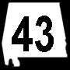 | North on AL-43, turn left onto AL-28 in Linden. Turn left onto US-80. Turn right onto AL-28. Turn right onto U.S. Highway 11. To locate a specific building on the UWA campus, use the UWA Interactive Campus Map

