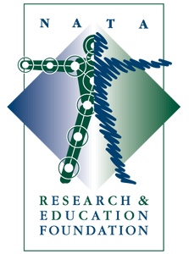

Investor Report for 2008

Only a small portion of NATA District membership dues approved by some individual districts directly supports the Foundation.
The Foundation relies heavily upon charitable giving and voluntary support to sustain all of its programs and activities, which are geared to supporting and advancing the athletic training profession through research and education.

Research Programs

- 18 Grants were awarded totaling over $432,641
- Approximately 200 Free Communications Presentations/Posters were presented at the NATA Annual Meeting in St. Louis
- 20 Foundation grant recipients presented their findings to the NATA membership in St. Louis
- Abstracts of original research were published in the summer supplement to the Journal of Athletic Training
- An original research supplement to the Journal of Athletic Training was made available to NATA members
- Grant Information Summaries, published from funded research projects, were made available to NATA members through the Foundation website and at National and District Meetings
- The Medal for Distinguished Athletic Training Research presented in honor of Joseph S. Torg, MD
- The New Investigator Award presented in honor of Freddie H. Fu, MD
- Doctoral Dissertation Award presented in honor of David H. Perrin, PhD, ATC
- Post Doctoral Research Grant continued funding

Education Programs

- $150,000 awarded through Foundation Scholarship Program (75 Scholarships)
- Presentation of Lecture Exchange Program with the AMSSM, AOSSM and ACSM
- Educational research/program grants

Capital Campaign

- 11 new endowments have already been established with 18 additional endowments being actively pursued.
- The principal driver of the Foundation’s Capital Campaign is a new and expanded vision for the future. The goal is to obtain a significant portion of the annual resources needed to continue advancing the profession from interest generated by the Foundation’s endowments.

For further information, please contact:

NATA Research and Education Foundation

2952 Stemmons Freeway

Dallas, Texas 75247
natafoundation.org
214-637-6282, fax 214-637-2206, e-mail johno@nata.org

