Stephen E. Bair ATC, District 2 Chair
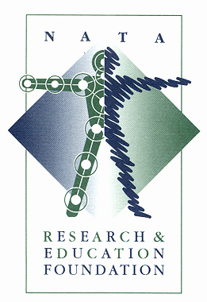
www.natafoundation.org
2009 NATA Fellows
David O. Draper
Jon Ty Hopkins
Michael R. Sitler
Endowed district 2 Masters level research grant will be named after Paula Sammarone Turocy and the endowed district 2 doctoral level research grant will be named after Michael R. Sitler
The Foundation sincerely appreciates the financial support provided by NATA in presenting an important summit titled “Advancing Outcomes of Care in Athletic Training: A Road Map for the Future.” This high-profile conference took place in Dallas, and was attended by approximately 40 high-profile researchers from across the country. The purpose of the summit was to serve as a catalyst for conducting athletic training outcomes research in a systematic and directed manner. It was thoroughly successful, and served as the “program announcement” for the $1 Million pledged by NATA, over a three year period, to fund athletic training outcomes research. This is yet another example of professional teamwork, and sends a strong, positive message to our constituents. To date, a little more than 1/3 of that fund has been committed to quality research. Several other viable projects are also being considered for funding.
The Foundation board recently completed a formal realignment of its goals, and has changed its governance structure to better respond to today’s challenges. We are fortunate to have board members in leadership roles who believe in this process, and who have made significant personal commitments to the success of these plans. Below is a schematic of the new governance structure
. district2 research grant awardees
- The Second Malacrea awardee: Christine Waters, BS, ATC “Effects of Massage on lymphangiogenesis and Inflammation”, University of Kentucky
- The First District 2 Research awardee: Allison S. Kim, BS, ATC/L
A Gender Comparison of Knee Stiffness Regulation Under Cognitive Load”
University of Delaware

. 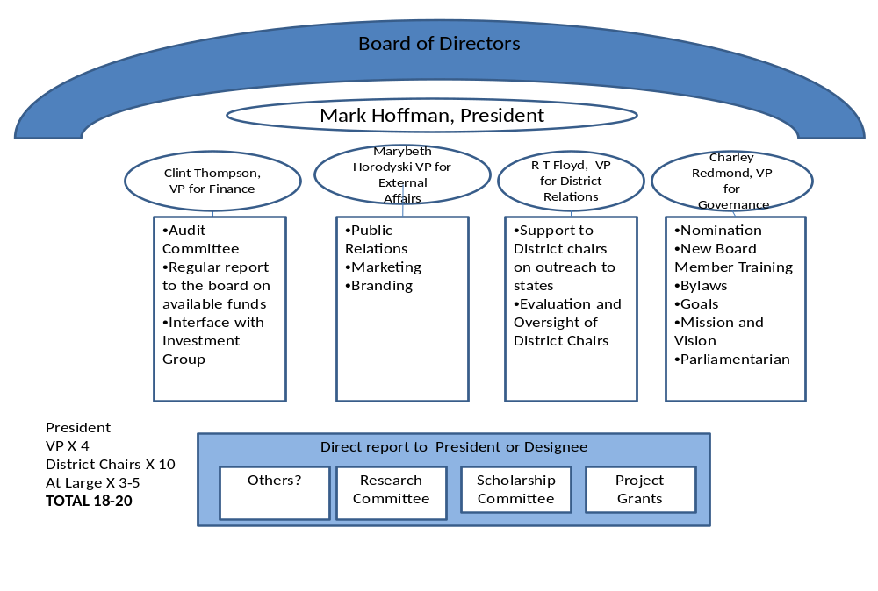
Scholarships-This program continues to be a terrific success. Sixty-nine (69) $2,300 scholarships will be presented to recipients at the NATA Annual Meeting in San Antonio. Over 40 different organizations are involved in providing the financial support to fund these awards. The Foundation Scholarship Committee has done an outstanding job in developing and maintaining these long-term relationships. The Foundation is proud to announce that 1,120 scholarships totaling more than $2 Million have been awarded to date.
Scholarship Endowment Funds – New partial and full endowment options have been offered to all of our sponsors beginning in 2009. We were extremely encouraged that numerous entities have made a commitment to endow their scholarship sponsorships. The earnings from these funds will enable us to fund these scholarship awards in perpetuity. This is certainly a source of pride for our board and committee members. It has also fostered a continuing energetic effort to endow as many Foundation programs and activities as possible.
district 2 scholarship awardees
- Rebecca Bedard ENTRY LEVEL
- Seth Bires ENTRY LEVEL
- Ian Cramer ENTRY LEVEL
- Megan Houston ENTRY LEVEL
- Meredith Link ENTRY LEVEL
- Brandi Lockerman ENTRY LEVEL
- Ashley Winkelspecht ENTRY LEVEL
- Kohei Kishimoto MASTERS

Funded Research Presentations – Another large group of applications for research grants has been received this year. Eleven of the Foundation’s grant recipients are scheduled to present their research findings at the 2009 NATA Annual Meeting. These developments clearly indicate an increasing interest and participation in meaningful research relative to the athletic training profession. The Foundation board authorized the inclusion of overhead costs (up to 15%) in grant application budgets, beginning in 2005. This expanded appeal has encouraged even more applicants. The Foundation has awarded a total of almost $3 Million in research grants. This is a significant accomplishment in the relatively short period of existence of the Foundation.
Research Results – Eighty-one Grant Information Summaries are now available. Each GIS provides summarized results of a research project the Foundation has funded. The plan is to continue our efforts to print several new summaries prior to each NATA Annual Meeting. We have 7 new summaries this year, which will be distributed from the Foundation booth and at all Free Communications sessions. All completed summaries are free to the membership upon request, and are included in materials distributed at all NATA District Meetings. They are also available on the Foundation web site at no cost. We feel this program provides a more widespread understanding among NATA members regarding the importance of funded research to the athletic training profession and its continued viability.
Free Communications Program – The Foundation received 343 abstracts for 2009. Once again, this is another indication of continued widespread interest and participation in research within the profession, in spite of the $25.00 submission fee. Recognition of outstanding student presentations is accomplished through oral presentations as well as poster presentations. Presenters are judged in their peer groups as doctoral, master’s or undergraduate students. The judging will be completed and the 2009 awards will be presented on Thursday afternoon (June 19) during the Distinguished Scholar Presentations Session. All of you are cordially invited to attend the session, and join in congratulating these developing leaders of scientific investigation in support of future athletic training professionals.
Annual Fund –The 2008 Building Our Foundation Annual Fund campaign generated over $170,000 in gifts from NATA members and state and district organizations. We are extremely grateful for the support provided for instituting dedicated dues to benefit the Foundation. Six of ten NATA districts have now formally provided for automatic partial distribution of dues income directly to the Foundation. These actions clearly demonstrate widespread support of the Foundation and its programs. Most significant is the fact that individual member support of the Foundation has now grown to about 75%! A primary emphasis will be to continue to educate the membership regarding the benefits of their Foundation individually, and to the athletic
Training profession in general. We project that continued energetic involvement by our state and district representatives will increase member giving each year.
Sponsorships – Sponsorship of Foundation programs is an important aspect of our overall annual campaign. The Foundation’s efforts in this area are assisted by terrific support from the NATA Marketing & Membership Department. We feel that our coordinated effort to offer opportunities and associated benefits to potential sponsors is a very effective approach. Foundation leadership is especially appreciative of this very productive team approach.

District 2 athletic Training Program Endowment Drive
- Leave a lasting legacy in the name your Athletic Training Program!
- Provide a mechanism for endowment funding within District 2
- Tax deductible contribution for the individual donors!
- INVESTING in the future of our chosen profession!
- Strengthen your ties to your professional association!
- Increase the knowledge base of the Athletic Training profession!
- Assist our students of today in becoming tomorrow’s leaders!
- SET THE EXAMPLE for others to follow to support and advance the mission of the NATA Foundation!
- Annual recognition of your investment as a conference through NATA Foundation outlets!
- All gifts over $1000 recognized on the Donor Honor Role for the capital campaign and gifts over $5000 receive a personalized commemorative gift!
Restrictions
- Choose one of the Four Current Growth Endowments in District 2:
- The Theodore Quedenfeld Research Endowment
- The Richard Malacrea Research Endowment
- The Edward Pillings Scholarship and Research Endowment
- The Stephen Bair Foundation Management Endowment
- Once the Goal is reached the Bair fund will add 5% of the corpus yearly to the Foundation for Administrative uses
- As is the case with all proposals, the Research Committee, Scholarship Committee or the Foundation Board will be responsible to review all proposals submitted as part of the normal awarding process

$500 per year raised by the Student Athletic Trainers
$500 per year donated by the Athletic Training Teachers and Clinical Staff
$500 raised through Alumni Support
Creates a $1500 Annual Pledge

Link to AT Program Pledge form

The capital campaign for researdch and education

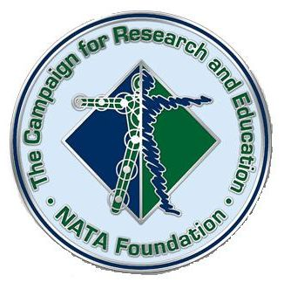
Status Report
Cash and Cash Pledges $1,358,691
Planned Gifts $153,867
Total $1,515,808

Endowment Projects
$2.5 Million Potential
$1,515,808 Received in Commitments to Date

LINK TO PLEDGE FORM TO DONATE TO EXISTING ENDOWMENTS

Ronnie Barnes Scholarship Endowment | $50,000
Richard Malacrea, AT Ret Research Endowment | $50,000
John A. Mayes, MS, ATC Scholarship Endowment | $50,000
PFATS Scholarship Endowments (Four Endowed) | $200,000
Rebecca Payne Memorial District 1 Scholarship Endowment | $52,000
District 2 Research Endowment (Doctoral endowment) | $50,000
District 2 Research Endowment Paula Sammarone Turocy Grant | $25,000
District 3 Research Endowment Mike Sitler Grant | $30,500
Frank George (EATA, D1 & D2) Scholarship Endowment | $50,000
Great Lakes Athletic Trainers' Society (District 4) Scholarship Endowments | $170,000
MAATA (District 5) Athletic Training Student Leadership Council Scholarship | $52,000
District 6 Research Endowment | $26,000
Bobby Barton (District 9) Scholarship Endowment | $52,000
District 10 Scholarship Endowment (Honoring Mark J. Smaha, MS, ATC) | $50,000
PFATS Doctoral Research Endowment | $52,000
Doctoral Dissertation Award Research Endowment  (In the name of David H. Perrin, PhD, ATC) | $25,000
Ethnic Diversity Advisory Committee (EDAC) Scholarship | $50,000
Joe Gieck EdD, AT Ret, PT Challenge Doctoral Research Endowment | $50,000
Louis R. Osternig, PhD Research Endowment | $25,000
Edward J. Pillings Scholarship and Research Endowment | $75,000
Ted Quedenfeld Research Endowment | $25,000
James R. Andrews, M.D. Excellence in Athletic Training Research Endowment | $250,000
ATSU AT Program Scholarship Endowment | $50,000
D6 SWATA Hall of Fame Scholarship Endowment | $50,000
District 7 Scholarship Endowment (Honoring Gary Delforge, AT Ret) | $50,000
Cantu-Guskiewicz Research Endowment for Sport Concussion | $25,000
Hughston Foundation Sports Medicine Scholarship Endowment | $50,000
Frank Medina Scholarship Endowment | $50,000
New Investigator Award Research Endowment  (In the name of Dr. Freddie and Mrs. Hilda Pang Fu) | $100,000
Postdoctoral Research Endowment | $25,000
Professional Rodeo Research Endowment | $25,000
Star Physical Therapy Endowment | $25,000
Stephen Earl Bair, MEd, ATC Foundation Management Endowment | $50,000
Unrestricted General Endowment | $25,000
Unrestricted General Research Endowment | $25,000
Unrestricted General Scholarship Endowment | $25,000
Women in Athletic Training Research Endowment | $25,000

Take a look at the above list. These Programs continue to need your support Make a sacrifice, you will be amazed at how good it makes you feel participating in the growth of our profession and knowing that you will be recognized for your commitment. these people have made that sacrifice(Capital Campaign Supporters.docx)
I started with a small monthly donation and have never missed the money, It just becomes part of your monthly budget!
Steve

Appendices:
Forms\Ed Pillings Fact Sheet.pdf
Forms\Ed Pillings Pledge Form.doc
Forms\Dict Malacrea Fact Sheet.pdf
Forms\Malacrea Pledge Card.doc
Forms\Ted Quedenfeld Fact Sheet.pdf
Forms\TQ Pledge Card.doc
Forms\Bair Endowment Fact Sheet.pdf
Forms\Bair Endowment Pledge Form.doc

